Jonathan Masukawa (33128396) Yan Zhao (31018809) Group #32

Based on our results, turnaround and waiting time wasn't shown to be better or worse depending on the relationship between average priority and average burst, as worded by the question. This is simply because the distribution is normalized. For example, burst 30 and average priority 2 will have the exact same statistical appearance as burst 30 and average priority 7, since the source data with average priority 7 will have the same shape, just with all process priorities on average being shifted up 5 more values than the priority 2 average source data. By increasing the burst from 30 to 70, we see the same shapes repeated but everything just takes longer.

I think what this question really means to ask, is how does the placement of the average burst distribution along a range of priorities affect the turnaround and waiting time. In this scenario, having processes with priorities inversely proportional to their CPU burst would greatly increase the performance of your algorithm, due to the fact that higher priorities will have lower burst times, and lower priorities will have higher burst time. Preemption will exaggerate this effect, and make the wait and turnaround times even less. This will mimic behavior similar to a SJF.

|  |  |
| --- | --- |
| Data Source Information | |
| Processes | 250 |
| Average Burst | Varies |
| Average Arrival | 20 |
| Average Priority | Varies |

Jonathan Masukawa (33128396) Yan Zhao (31018809) Group #32

|  |  |  |  |  |  |  |  |  |
| --- | --- | --- | --- | --- | --- | --- | --- | --- |
| Processes - 250, Avg Burst - 30, Avg arrival - 20, Avg Priority - 2 | | | |  | Processes - 250, Avg Burst - 30, Avg arrival - 20, Avg Priority - 7 | | | |
| **Priority (non-preemptive) B30 P2** | | | |  | **Priority (non-preemptive) B30 P7** | | | |
|  | **Wait** | **Response** | **Turnaround** |  |  | **Wait** | **Response** | **Turnaround** |
| **Min** | 0 | 0 | 1 |  | **Min** | 0 | 0 | 1 |
| **Mean** | 784.44 | 784.44 | 812.22 |  | **Mean** | 789.02 | 789.02 | 816.8 |
| **Max** | 6754 | 6754 | 6795 |  | **Max** | 6383 | 6383 | 6424 |
| **StdDev** | 1665.53 | 1665.53 | 1687.69 |  | **StdDev** | 1678.39 | 1678.39 | 1700.3 |
|  |  |  |  |  |  |  |  |  |
| Processes - 250, Avg Burst - 70, Avg arrival - 20, Avg Priority - 2 | | | |  | Processes - 250, Avg Burst - 70, Avg arrival - 20, Avg Priority - 7 | | | |
| **Priority (non-preemptive) B70 P2** | | | |  | **Priority (non-preemptive) B70 P7** | | | |
|  | **Wait** | **Response** | **Turnaround** |  |  | **Wait** | **Response** | **Turnaround** |
| **Min** | 0 | 0 | 48 |  | **Min** | 0 | 0 | 29 |
| **Mean** | 5585.54 | 5585.54 | 5652.56 |  | **Mean** | 5562.49 | 5562.49 | 5629.52 |
| **Max** | 16488 | 16488 | 16569 |  | **Max** | 16046 | 16046 | 16121 |
| **StdDev** | 1827.88 | 1827.88 | 2031.47 |  | **StdDev** | 1649.16 | 1649.16 | 1873.11 |
|  |  |  |  |  |  |  |  |  |
| Processes - 250, Avg Burst - 30, Avg arrival - 20, Avg Priority - 2 | | | |  | Processes - 250, Avg Burst - 30, Avg arrival - 20, Avg Priority - 7 | | | |
| **Priority (preemptive) B30 P2** | | | |  | **Priority (preemptive) B30 P7** | | | |
|  | **Wait** | **Response** | **Turnaround** |  |  | **Wait** | **Response** | **Turnaround** |
| **Min** | 0 | 0 | 1 |  | **Min** | 0 | 0 | 1 |
| **Mean** | 792.26 | 658.16 | 820.04 |  | **Mean** | 806.95 | 660.7 | 834.73 |
| **Max** | 6754 | 6754 | 6795 |  | **Max** | 6577 | 6148 | 6612 |
| **StdDev** | 1703.43 | 1543.63 | 1725.81 |  | **StdDev** | 1707.33 | 1512.14 | 1729.61 |
|  |  |  |  |  |  |  |  |  |
| Processes - 250, Avg Burst - 70, Avg arrival - 20, Avg Priority - 2 | | | |  | Processes - 250, Avg Burst - 70, Avg arrival - 20, Avg Priority - 7 | | | |
| **Priority (preemptive) B70 P2** | | | |  | **Priority (preemptive) B70 P7** | | | |
|  | **Wait** | **Response** | **Turnaround** |  |  | **Wait** | **Response** | **Turnaround** |
| **Min** | 0 | 0 | 22 |  | **Min** | 0 | 0 | 22 |
| **Mean** | 5640.5 | 5517.91 | 5707.52 |  | **Mean** | 5657.4 | 5469.43 | 5724.43 |
| **Max** | 16488 | 16488 | 16569 |  | **Max** | 16075 | 16075 | 16156 |
| **StdDev** | 2010.87 | 1751.6 | 2197.33 |  | **StdDev** | 1935.22 | 1549.72 | 2128.45 |

Jonathan Masukawa (33128396) Yan Zhao (31018809) Group #32

|  |  |  |  |  |  |  |  |  |
| --- | --- | --- | --- | --- | --- | --- | --- | --- |
| Wait | | | | | | | | |
|  | Pri (np) B30 P2 | Pri (np) B30 P7 | Pri (np) B70 P2 | Pri (np) B70 P7 | Pri (p) B30 P2 | Pri (p) B30 P7 | Pri (p) B70 P2 | Pri (p) B70 P7 |
| **Mean** | 784.44 | 789.02 | 5585.54 | 5562.49 | 792.26 | 806.95 | 5640.5 | 5657.4 |
| **Max** | 6754 | 6383 | 16488 | 16046 | 6754 | 6577 | 16488 | 16075 |
| **StdDev** | 1665.53 | 1678.39 | 1827.88 | 1649.16 | 1703.43 | 1707.33 | 2010.87 | 1935.22 |
|  |  |  |  |  |  |  |  |  |
| Response | | | | | | | | |
|  | Pri (np) B30 P2 | Pri (np) B30 P7 | Pri (np) B70 P2 | Pri (np) B70 P7 | Pri (p) B30 P2 | Pri (p) B30 P7 | Pri (p) B70 P2 | Pri (p) B70 P7 |
| **Mean** | 784.44 | 789.02 | 5585.54 | 5562.49 | 658.16 | 660.7 | 5517.91 | 5469.43 |
| **Max** | 6754 | 6383 | 16488 | 16046 | 6754 | 6148 | 16488 | 16075 |
| **StdDev** | 1665.53 | 1678.39 | 1827.88 | 1649.16 | 1543.63 | 1512.14 | 1751.6 | 1549.72 |
|  |  |  |  |  |  |  |  |  |
| Turn Around | | | | | | | | |
|  | Pri (np) B30 P2 | Pri (np) B30 P7 | Pri (np) B70 P2 | Pri (np) B70 P7 | Pri (p) B30 P2 | Pri (p) B30 P7 | Pri (p) B70 P2 | Pri (p) B70 P7 |
| **Mean** | 812.22 | 816.8 | 5652.56 | 5629.52 | 820.04 | 834.73 | 5707.52 | 5724.43 |
| **Max** | 6795 | 6424 | 16569 | 16121 | 6795 | 6612 | 16569 | 16156 |
| **StdDev** | 1687.69 | 1700.3 | 2031.47 | 1873.11 | 1725.81 | 1729.61 | 2197.33 | 2128.45 |

Jonathan Masukawa (33128396) Yan Zhao (31018809) Group #32

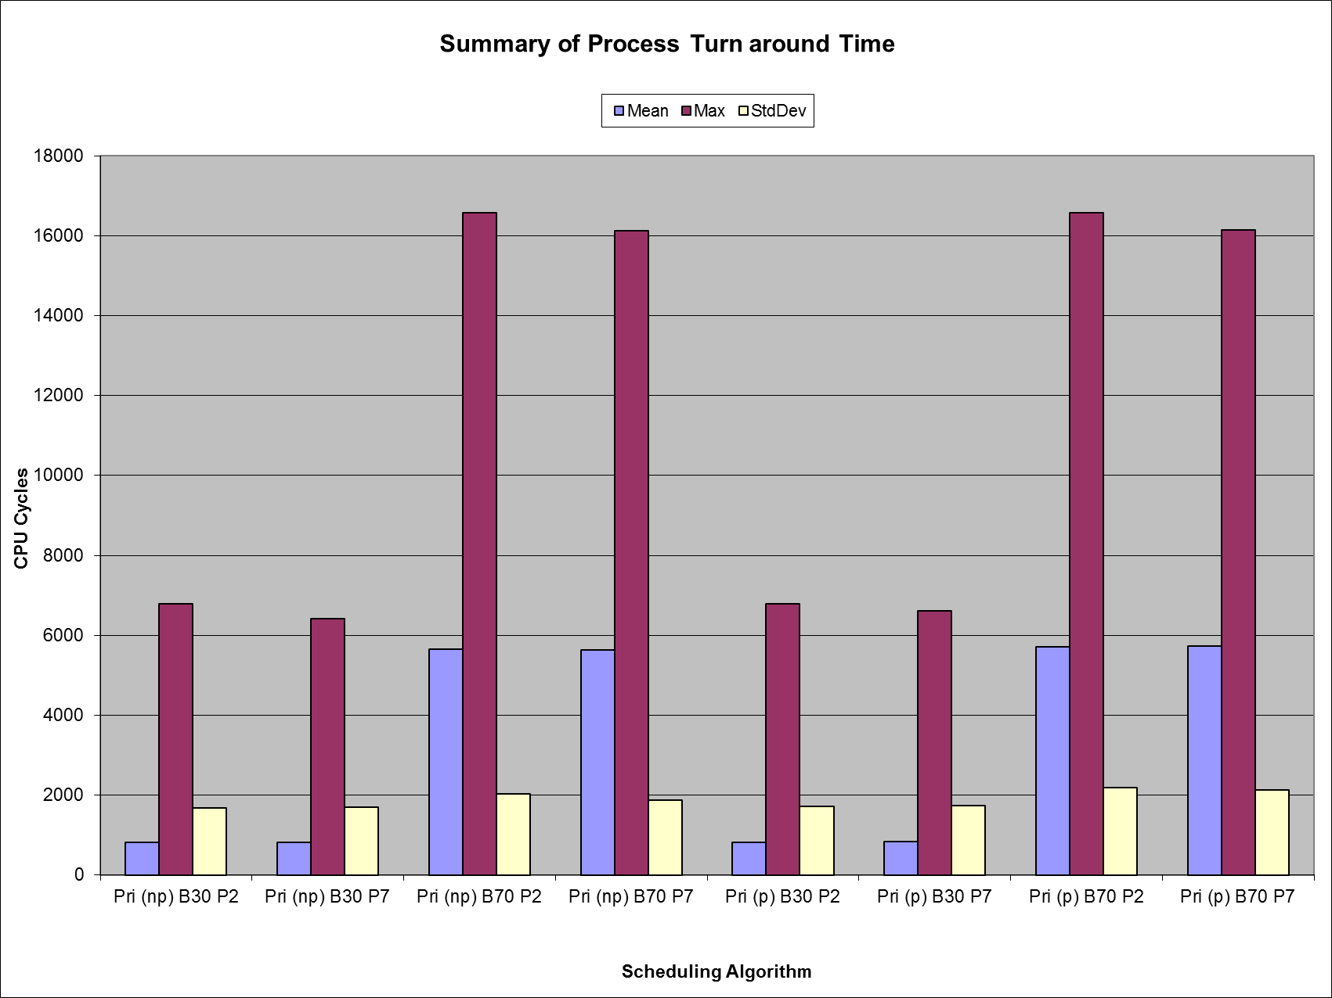

Jonathan Masukawa (33128396) Yan Zhao (31018809) Group #32

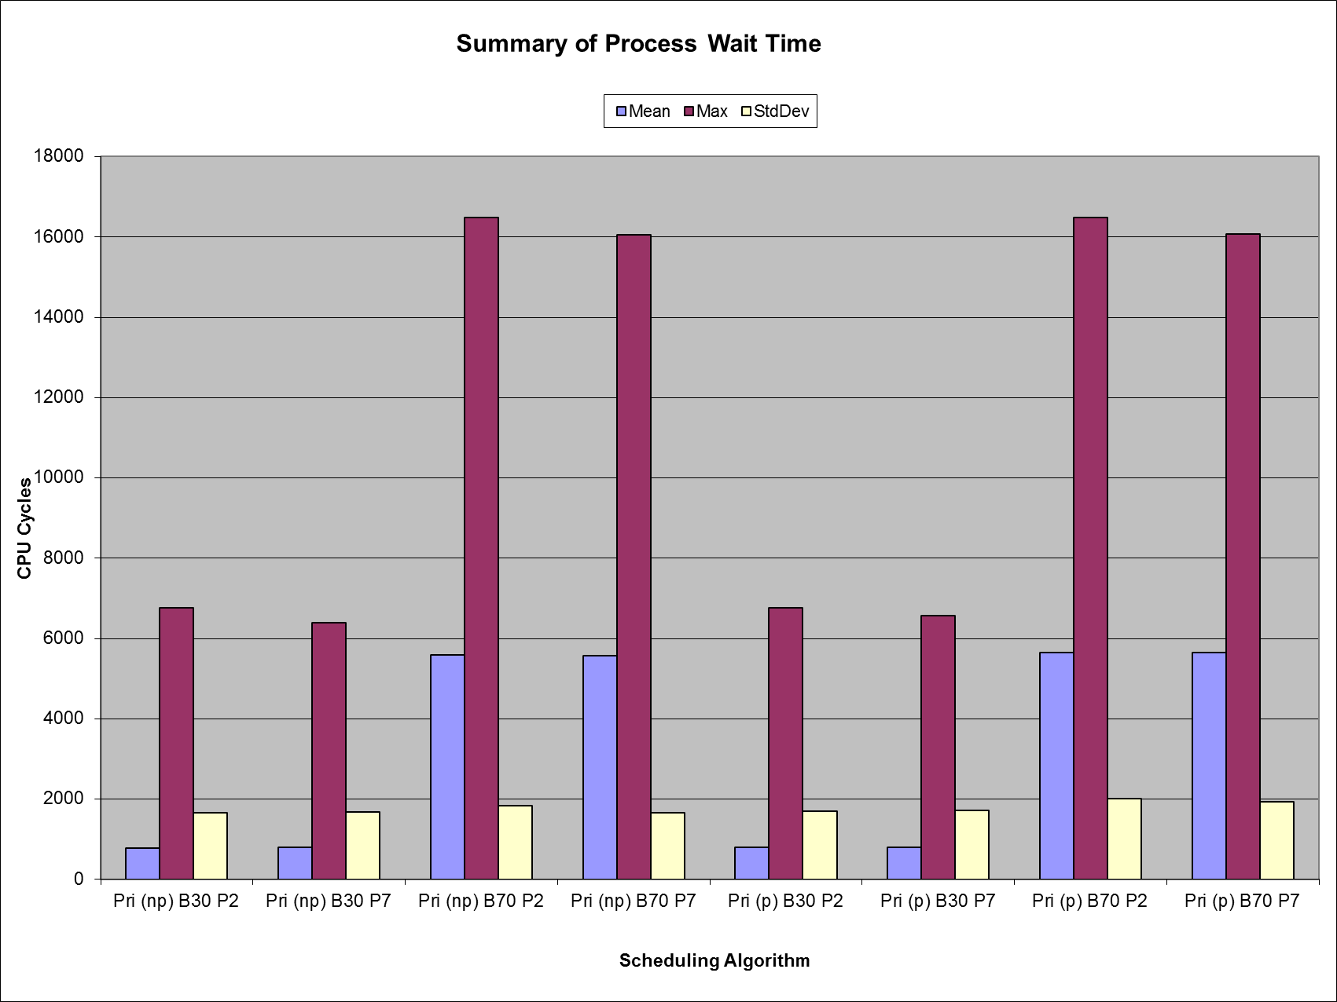

Jonathan Masukawa (33128396) Yan Zhao (31018809) Group #32

